**Steps on performing carbon staking on the testnet**

1. Go to <https://dev-wallet.zilliqa.com/generate>
   1. Create a passphrase
   2. Generate a keystore file
2. Select Send Zilliqa Tab
   1. <https://dev-wallet.zilliqa.com/send>
   2. Enter your keystore file and your passphrase
   3. Retrieve your zilliqa address, Copy it
3. Select Zilliqa Faucet
   1. <https://dev-wallet.zilliqa.com/faucet>
   2. Paste your zilliqa address
   3. Run Faucet
4. Go to <https://ide.zilliqa.com/#/>
   1. 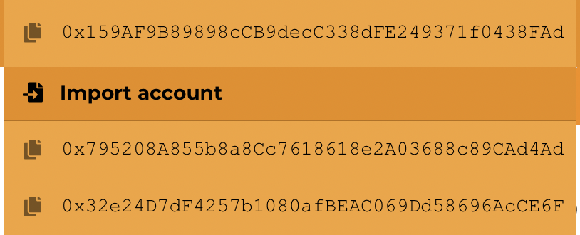

Import account and select your keystore file and key in your passphrase if required.

* 1. 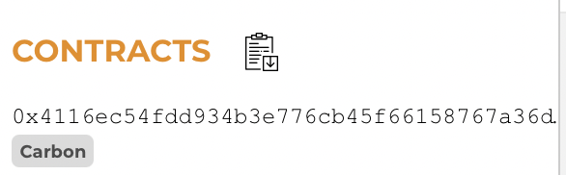

Click on the Icon beside Contracts at the bottom left corner of your screen

* 1. Import in the contract for the Testnet Carbons to retrieve 1,000 Carbons
  2. 0x3e1b442f12c57449464c7daa162803765606b81f
  3. 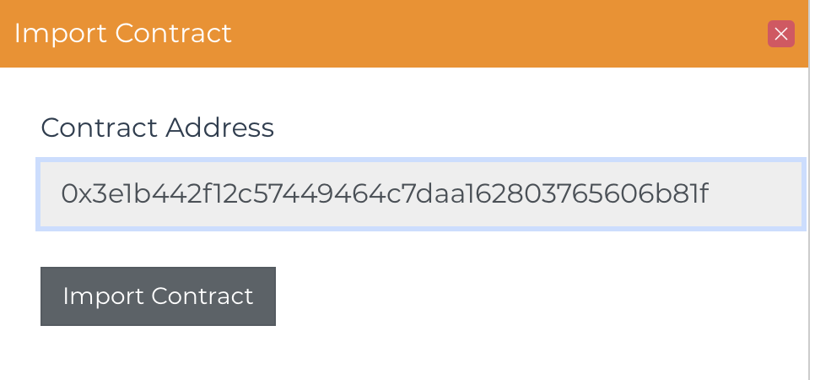  
     Keying this address into the import contracts
  4. 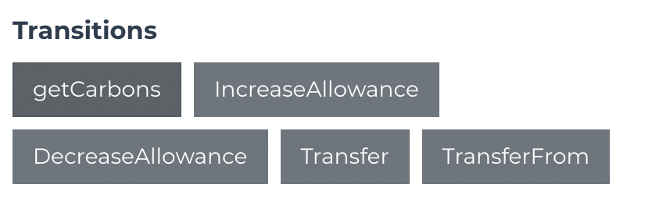  
     Select getCarbons and key in your passphrase and select call Transition
  5. 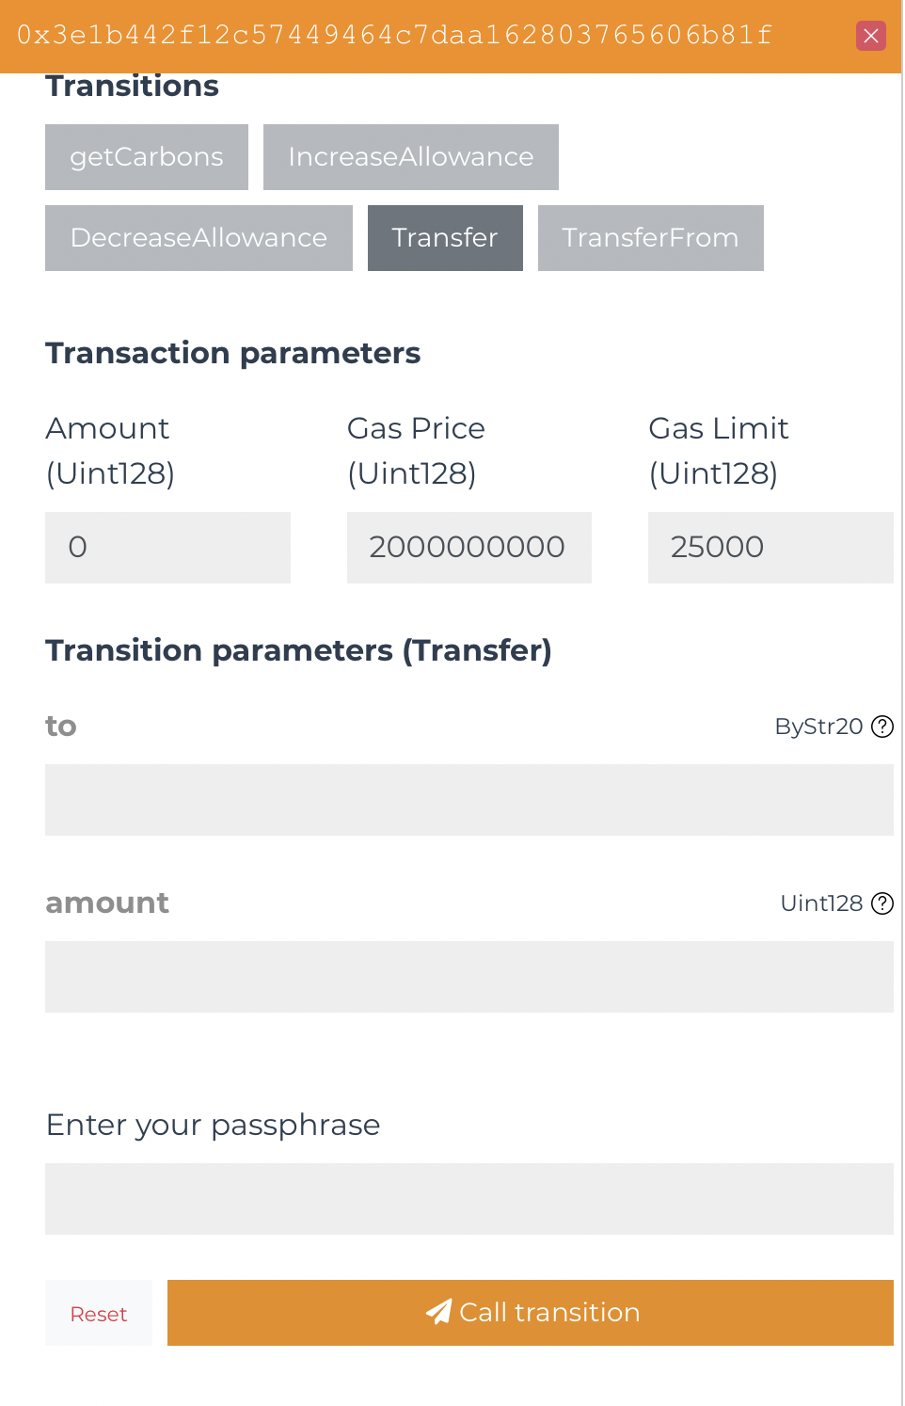  
     Select Transfer and send the carbon to  
     0xa26cb7d77bc6c4b47ed0e6c4209e61be33ef822f  
     This is the staking contract address minimum amount of Carbons required is 50 appended by 8 zeros behind.
  6. <https://devex.zilliqa.com/address/0xa26cb7d77bc6c4b47ed0e6c4209e61be33ef822f?network=https://dev-api.zilliqa.com>  
     To view your stake, you could view it within the address below

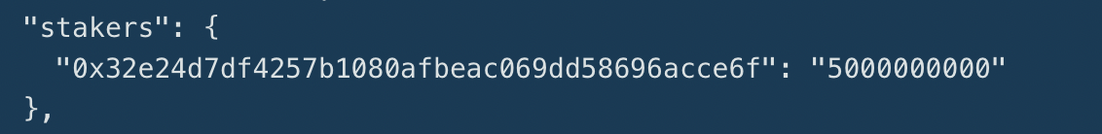

* 1. Any Bugs found please do report to Adam on telegram or the form filled